Task 10 - Reproductive technologies and STI’s test
SECTION A – MULTIPLE CHOICE ANSWERS (10 marks)
Put a cross(X) through your choice of answer. If you make a mistake, scrub out your answer, then select a new one. Complete ALL short answer questions in the spaces provided.

1. | a | b | c | d |  | 6. | a | b | c | d
2. | a | b | c | d |  | 7. | a | b | c | d
3. | a | b | c | d |  | 8. | a | b | c | d
4. | a | b | c | d |  | 9. | a | b | c | d
5. | a | b | c | d |  | 10. | a | b | c | d
SECTION B – SHORT ANSWER (35 marks)
- State three main factors affecting fertility in a male and a female:
Causes of Infertility
Male | Female
(6 marks)
- Complete the following table:

STI | Caused by which organism? | Early Symptoms | Treatment(s)
Gonorrhoea
Genital Warts
Genital Herpes
Chlamydia
(12 marks)
3. There are a number of reproductive technologies available for couples who have been considered infertile.
a. What is the difference between the terms sterile and infertile?
(2 marks)
b. Two technologies that are available are called GIFT and ZIFT. How are they SIMILAR to each other? How are they DIFFERENT to each other?
(3 marks)
c. State and describe two impacts that aging has on a woman’s fertility health
(2 marks)

4. The graph on the next page is incomplete. It shows the number of people who contracted gonorrhoea or chlamydia in 2016.
a) Complete the graph by labelling the axis and adding an appropriate title. (3 marks)
b) What is the independent variable? _________________________________________ (1 mark)
c) What is the dependent variable? ___________________________________________(1 mark)
d) Name two (2) variables that were kept the same.
(2 marks)
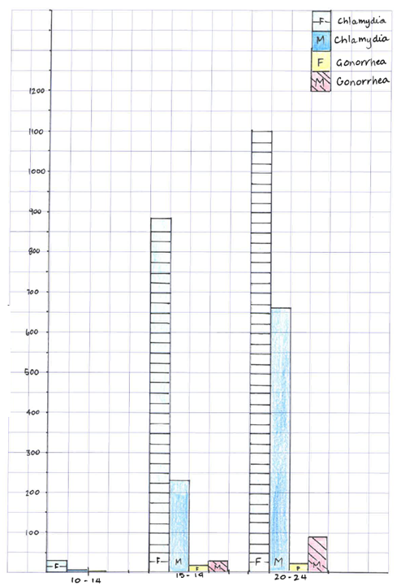

e) Which age group has the highest cases of females with chlamydia? __________(1 mark)
f) Why do females have more cases of chlamydia than males?
(2 marks)
END OF TEST

